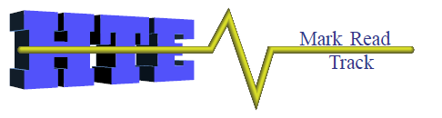

Plantwatch® 4.0 Overview

This document contains a brief overview of Plantwatch quick builder software.

HTE inc. is well known for developing high-value software solutions based on advanced IT platforms. One of our most innovative products to date is Plantwatch®, a Tracking and Production Management system. Plantwatch is an open platform combined with software applications that manage the day-to-day plant operations and the plant’s integration to the extended enterprise and its supply chain. Based on a flexible object-modeling framework, Plantwatch is ideal for customers seeking the benefits of a tailored solution with the lowest cost and shortest implementation time. 1 day of training is all it takes.

Increase company revenue and competitiveness

- Lower cost per unit
- Track product in real time
- Decrease production cycles and scrap

Increase effectiveness and reduce costs

- Reduce Work in Process
- Reduce scrap
- Improve first pass yield
- Control processes and acquire data

Reduce liability

- Track defects
- Reduce warranty claims
- Complete product genealogy
Common applications are : traceability, labor/job tracking, cell control, machine control, data collection, error proofing, inventory control , process management, operator interface and many more.

Plantwatch uses the Configuration tree along with Logic Charts to make application
development easy and fast! Radio button configuration makes it so easy :

"Even End users can do it"

Plantwatch is designed to capture and communicate real-time manufacturing data from the shop floor to the people and systems that need it, when they need it. Information provided by Plantwatch helps our customers make better-informed decisions and reduces manufacturing costs and lead times. Plantwatch is designed to track all aspects of manufacturing production, providing defect tracking, traceability, error proofing and providing a complete and accurate product genealogy—so you can reduce work in progress, lower cost of errors, and lower cost of compliance with your customer requirements. The result is increased revenues, improved customer satisfaction, and reduced manufacturing costs.

Plantwatch can help you increase your manufacturing effectiveness and reduce costs, because it:
- Reduces scrap costs
- Reduces inventory through more precise management of product and materials in the production cycle
- Helps improve production yield while lowering cost per unit of production thus expanding profit margin and revenues

Plantwatch helps you reduce your exposure to liability, in the following ways:
- Defect tracking provides accurate identification of defect location, defect cause and defect impact on inventory produced
- Allows you to stand behind product warranties while limiting your exposure to costly response to warranty terms and conditions invoked when the customer detects product defects
- Provides information in real time to reduce manufacturing costs, limit liability to production errors, and increase product revenue

Plantwatch Defined

Plantwatch consists of several flexible software components that provide manufacturers both real-time and historical views into their manufacturing environment to increase company revenue, competitiveness, and effectiveness, and reduce costs and liability.

Features
Plantwatch is scalable from the smallest to the most complex manufacturing installations. It is the culmination of leveraged technology developments (distributed application design, client-server systems, object-oriented programming methodologies, multi-tiered architecture systems) and a broad understanding of manufacturing, applied to the solution of business and integration needs.
By consolidating meaningful online information with existing knowledge of the activities necessary to make the finished products, Plantwatch allows manufacturers to optimize existing manufacturing processes and the manufacturing supply chain. Plantwatch complements the enterprise planning systems (ERP) and supply chain management systems (SCM) by capturing the manufacturing data in sufficient detail to allow rapid identification of the cause of problems with fast reaction to limit the financial impact of these problems.

Architecture
- Plantwatch's Architecture is compliant with Microsoft's .NET for Manufacturing, and is the foundation on which the application is built.
- Plantwatch has a multi-user, multi-tier architecture. A typical configuration is shown below.

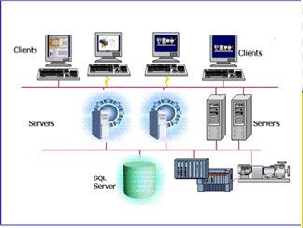

Configuration Explorer
Configuration Explorer is the simple-to-use tool that is used to configure Plantwatch to model your unique process. Configuration Explorer's standard tree-view, devices and Logic Charts make application development easy and fast. Using a sophisticated graphical development interface, you define your final products, consumables, inventory locations, quantities, the steps in your manufacturing process, and data to be collected along the way. Configuration Explorer is used to develop applications and also to modify them during run time.

Tree View
Tree View allows you to add or delete components from you application such as:
Devices to talk to, for example a camera, bar code reader or PLC
Local variables to store values
Logic Charts to perform logic and cause real world actions
SQL Databases to connect to for data storage
Bar Code printers
Digital I/O 24 vdc

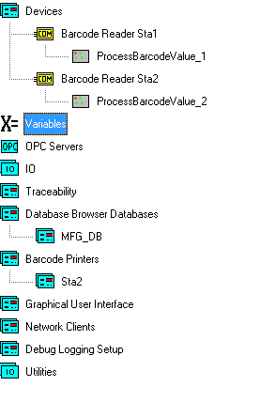

Device
Devices connect the application to the real world for data. Here we have a device called Barcode Reader Sta1, configured as a Com Port device. Each time the Barcode device gets a value from the Barcode Reader through the com port, it will run its logic charts. (Logic charts are described in the next section of this document) Device examples: camera, PLC register, Ethernet devices, RS232 devices,

The following image shows one logic chart, “ProcessBarcodeValue_1”, that will run. It is common to have many Logic Charts associated to a device.
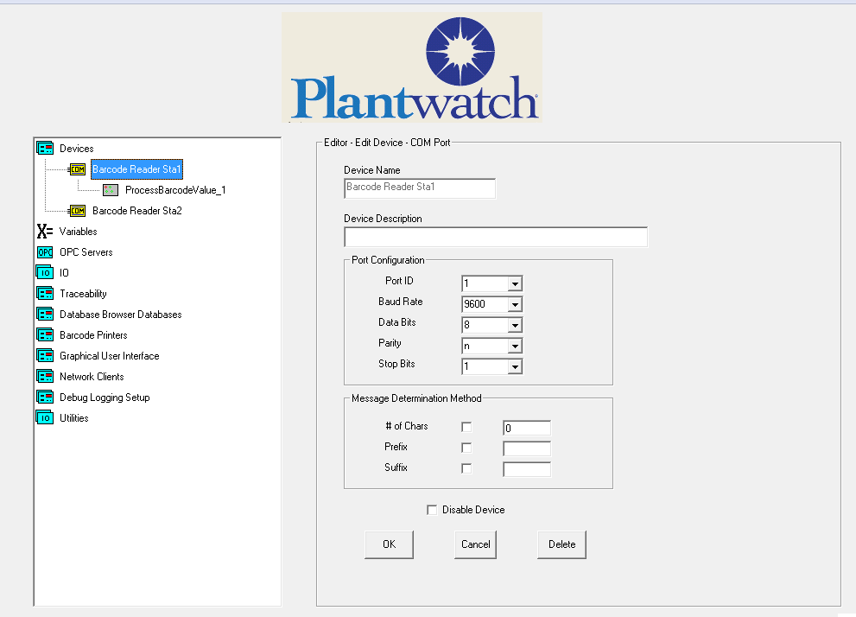

Logic Charts
A Logic Chart is a collection of Logic Cells that can be used to create logic and cause events. Each logic chart is associated to a device which causes the chart to be run when the device has an event, for example getting a new value from a barcode reader or a register change in a PLC.

You setup the Logic Cells like a flow chart, where each call can be logical or perform an action.

The logic chart will run from the upper left to the lower right, processing each cell it gets to. If it encounters an IF cell that is not true, it will stop execution on that row of cells
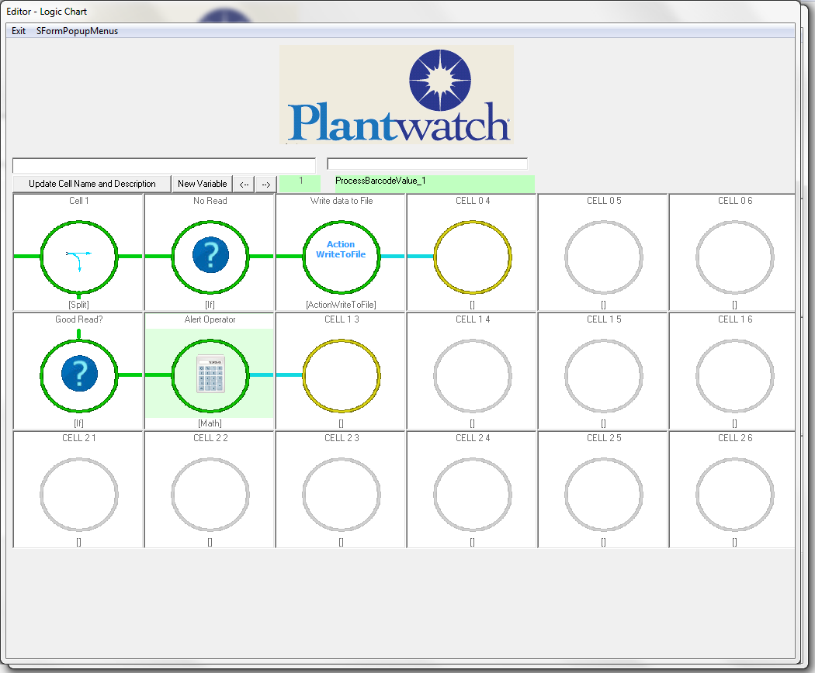

Logical type cells including If, IfThen, and Split types, allow you to control the path of execution through the flow chart.

Action type cells, such as WriteToFile, allow you to create actions in the real world and set values into variables used throughout the application.

The logic chart above will:
Determine if it was a good read by looking for the constant string “NoRead” coming from the reader.
If it was a good read it will write the barcode read string to file c:\Data\BarcodeData.csv.
If it was not a good read it will send a “Bad Barcode Read” message to the operator screen.

Logic Chart Cell
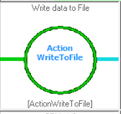
The Logic Chart Cells can perform to either act as a logic control or be an action. There are many actions to choose from including
Database Browser – Read or write to a Database
Write to File – Write to text file to be opened with excel
List – Allows you to create and manage collections
Math - Create a mathematical expression including Set, Add, Append, Clear
Substring – Pull parts out of a string based on starting position and length.
Search for String – Checks to see if a value is present
File Manager – Copies, Creates or deletes files and folders on the hard drive
Traceability – Captures Genealogy data as parts are manufactured based on part unique number
WriteToDevice – Send data back to any device
WriteToIO – Change the state of one of the digital outputs.
WriteToOPC – Write a value directly into a PLC, with no PLC programming required
WriteToFile – Write data out to ASCII files such as text and csv
ReadFromFile – Read a text file into Plantwatch
StoredProcedure – Call a SQL database stored procedure
PrintBarCode – Print directly to a barcode printer
TriggerExe – Call an executable or batch file passing it parameters
ChangeScreen – Change the user screen to a different user screen

In this cell we will write the barcode device value to file c:\Data\BarcodeData.csv.

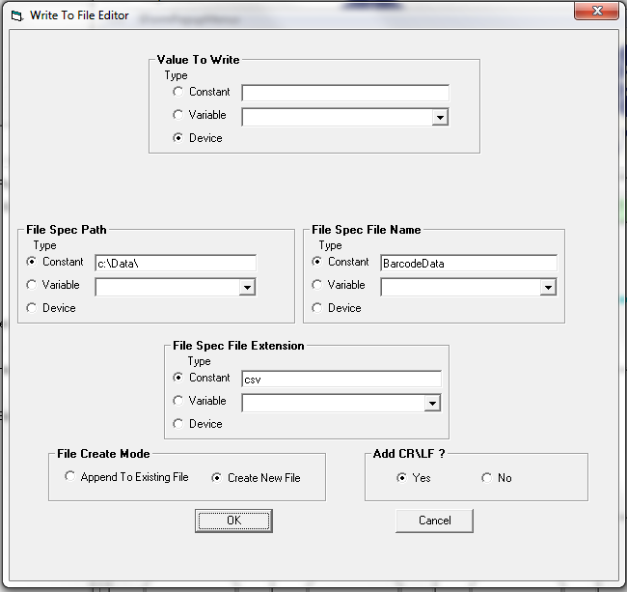

IO

Plantwatch has digital IO in several configurations. You can have one dedicated 8 in/8 out block or have a backplane and add up to 8 IO modules. RFID reader modules are available.

Barcode Printing

Plantwatch connects directly to Barcode printers to print custom designed barcodes.

OPC

Plantwatch uses OPC to talk directly to any common PLC. Read or Write with no PLC programming.

Screen Builder

The ease of the graphical development system allows you to quickly create an unlimited number of screens, custom made for your system. Graphics operations:

Buttons can be used to change screens, cause logic charts to run and set constant values into tags.

Data can be displayed via simple output text fields, lists or drop downs. Lists or drop downs could be populated with a unknown number of values such as the available jobs to run.

Lists and drop downs allow the operator to click on a specific value to select it, such as choosing a job to run. The selected value can be used in the logic charts.

Images can be displayed, either static or controlled by tags.
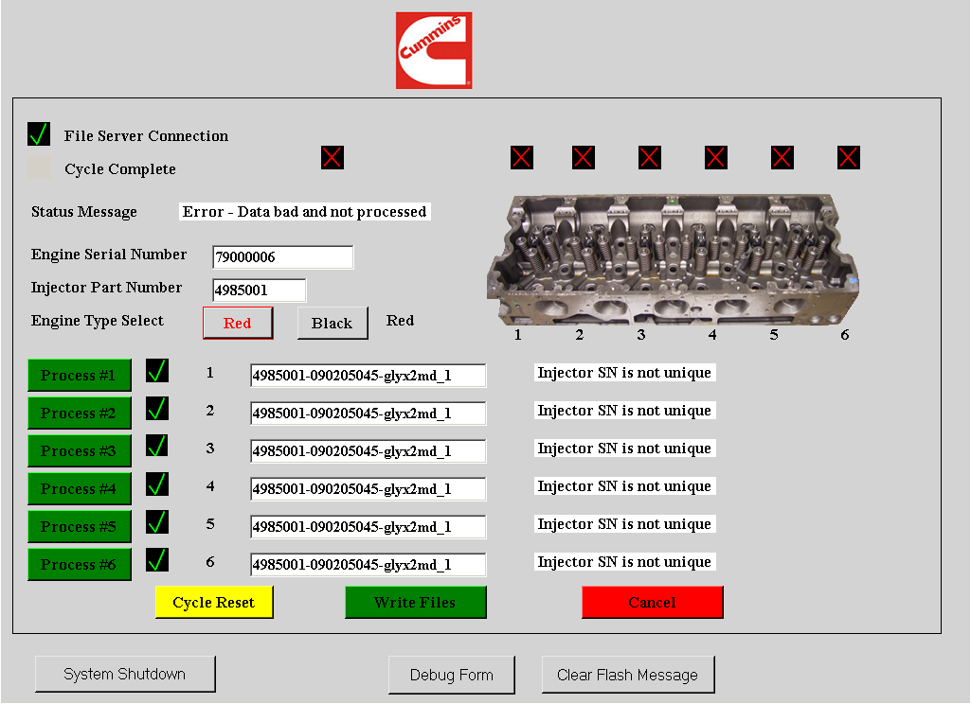
This screen directs the user to scan 6 fuel injectors and then validates the data before sending it to the customer’s data system.

First the operator clicks on the green Process buttons to select the injectors he is replacing. Then the operator uses a hand scanner to scan the diesel fuel injectors. When the operator is done they will click on the Write Files button to save the data.

At that time the information is compared to the predicted data coming from the failsafe PLC. As long as the data is good it will be manipulated into coded files to be used with the engine programming tool. The screen will then tell the operator the result.

Live Monitor
Live Monitor is a function that allows you to see into your system in real time. Watch live as the system functions in front of your eyes. This is a great tool for debugging an application as well.

Each action cell is colored green or read based on whether that action cell ran the last time the Logic chart ran.

Each action has its last ran time stamp, how many times it has ran and the details of the last action performed available. Simply click on a cell and it’s detailed data will be displayed in the lower portion of the screen.

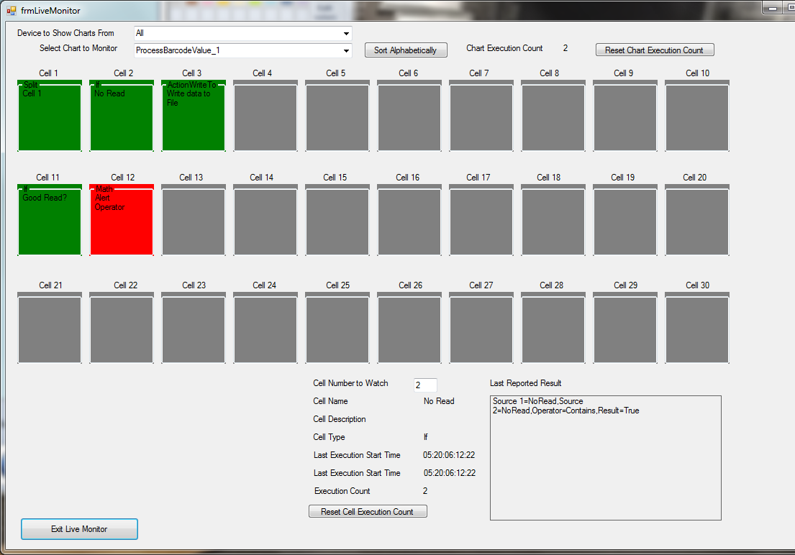

Thank you for reviewing Plantwatch software. For a demonstration copy or live demo please call
HTE at 248-371-1918 or e mail sales@hte.net

